Case Study Documentation

This document contains all the commands and details for all the steps that I followed to complete the case study.

# Milestone-1:

### Basic Git commands to create repo, branches, get code, commit, merge

* Create a new Branch:
  + git branch <branch-name>
* Switching to a branch:
  + git checkout <branch-name>
* For commit code to branch:
  + git commit -m “[Commit message]”
* Pushing a branch to Git:
  + git push origin <branch-name>
* Pulling from a branch to local:
  + git clone <https://shubhamsharma17@dev.azure.com/shubhamsharma17/CaseStudy/_git/CaseStudy>

### All Azure resources should be tagged inside a Resource Group

As part of the case study we need to create all the services/components under only one resource group. Here I am using following command to create a new Resource group.

* az group create --location eastus --name RGCaseStudy

### Use ARM templates and configure the Azure infrastructure using Azure Devops

I have created the ARM Template in the VS Code to create Storage Account, Virtual Network, Subnet and Azure Kubernetes Service (AKS). And then deployed the template in the Azure Portal using the following command.

* az deployment group create --resource-group RGCaseStudy --template-file ARMTemplate.json

Along with this I have also created Azure Container Registry (ACR) by using below command

* az acr create --resource-group myResourceGroup --name AksAcr6276 --sku Basic

In the below screenshot in Azure Portal, I have one resource group (RGCaseStudy), in that resource group I have AKS, VNET and ACR service

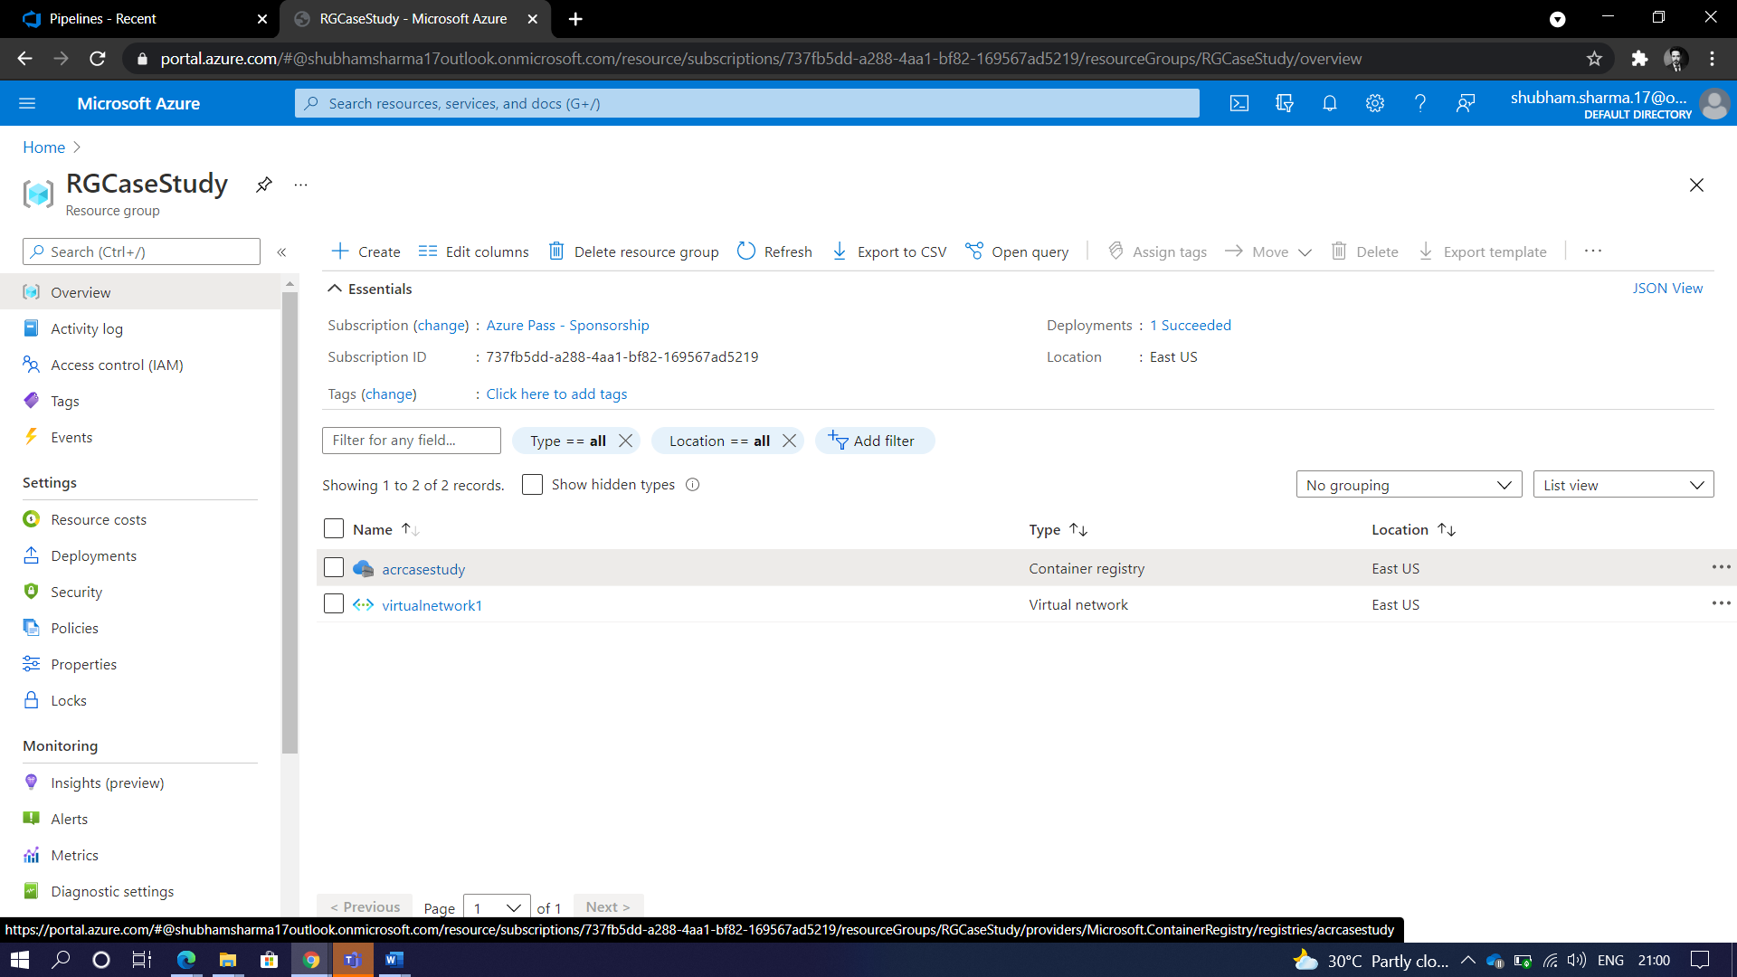

I have created a new Azure Container Registry and pushed the docker image into that ACR. By I have followed below steps to do that:

* Login to the ACR using the following command
  + az acr login --name acrcasestudy
* Tag a docker image with the ACR
  + docker tag mcr.microsoft.com/hello-world acrcasestudy.azurecr.io/hello-world:v1
* Deploy the docker image into the ACR
  + docker push acrcasestudy.azurecr.io/hello-world:v1
* Use following command to verify the image is deployed to the registory
  + az acr repository list --name acrcasestudy --output table
* Run the docker image using below command
  + docker run acrcasestudy.azurecr.io/hello-world:v1

Now we need to attach the AKS with the ACR. To do that, I have run the following commands

* az acr create --resource-group RGCaseStudy --name akscasestudy --sku Basic
* az aks create -g akscasestudy -n RGCaseStudy --location eastus --attach-acr acrcasestudy --generate-ssh-keys
* az connectedk8s connect --name RGCaseStudy --resource-group akscasestudy aks update -n akscasestudy -g RGCaseStudy --attach-acr acrcasestudy

I have committed and pushed the code into Azure Devops Repository and created a pipeline and run Yaml file

